**Union and Draw School**

Comp 3322 - Software Engineering

Final Project Report

**Submitted by**

Ihsan Karagol

Damlanur Onat

Rowshen Paltayew

Bakybek Tazhibaev

Computer Science Department

May 07, 2017

**Table of Contents**

1. **Introduction**
2. **Project Organization**

2.1 Software Process Model

2.2 Roles and Responsibilities

1. **Project Management Plan**

3.1 Tasks

3.2 Assignments

3.3 Timetable

1. **Additional Material**

5.1 Screenshots

INTRODUCTION

We did education website about student life, like which places they are living with, and how students can help according to reach good grades, and school activities and events

1.1.1 Context of the project.

This project related to high school students. And it will help them to improve their success and attend to good universities.

1.1.2 Explain the need and how this project will address it?

People will need this project since it is not so professional website for only adult people, we use curves for div boxes and we use some animation pictures it will help highschool students to understand and not get bored.

2 PROJECT ORGANIZATION

2.1 Software Process Model

 We selected Software **Prototyping Process model** for our website project. It went The advantages of using Prototype model in our project were: We could better understand requirements for user functionality, and interface, since we can actually going into final development stage. It enabled us to add

3 PROJECT MANAGEMENT PLAN

3.1

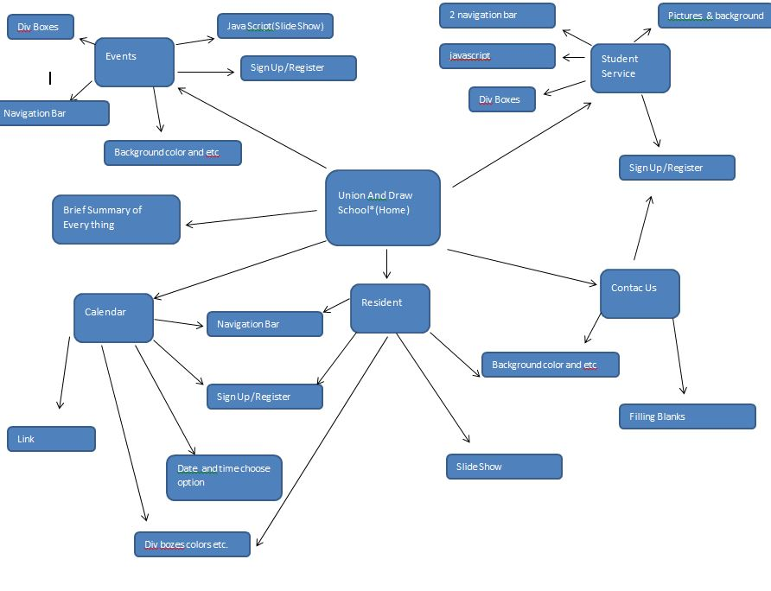

3.2 Assignments

Who worked on which part.

* Ihsan Karagol
  + Home
  + Sign Up
  + Student Service
  + Login/Register
* Damlanur Onat
  + Resident
* Rowshen Paltayew
  + Calendar
* Bakybek Tazhibaev
  + Events

4 TEST

4.1 Features Tested

1. Main Html
2. Logo sizes
3. Website name
4. Student Service
5. Resident
6. Calendar
7. Events
8. Sign Up /Login page
9. Colors and design

5.1 Saved Place for videos and screen shots

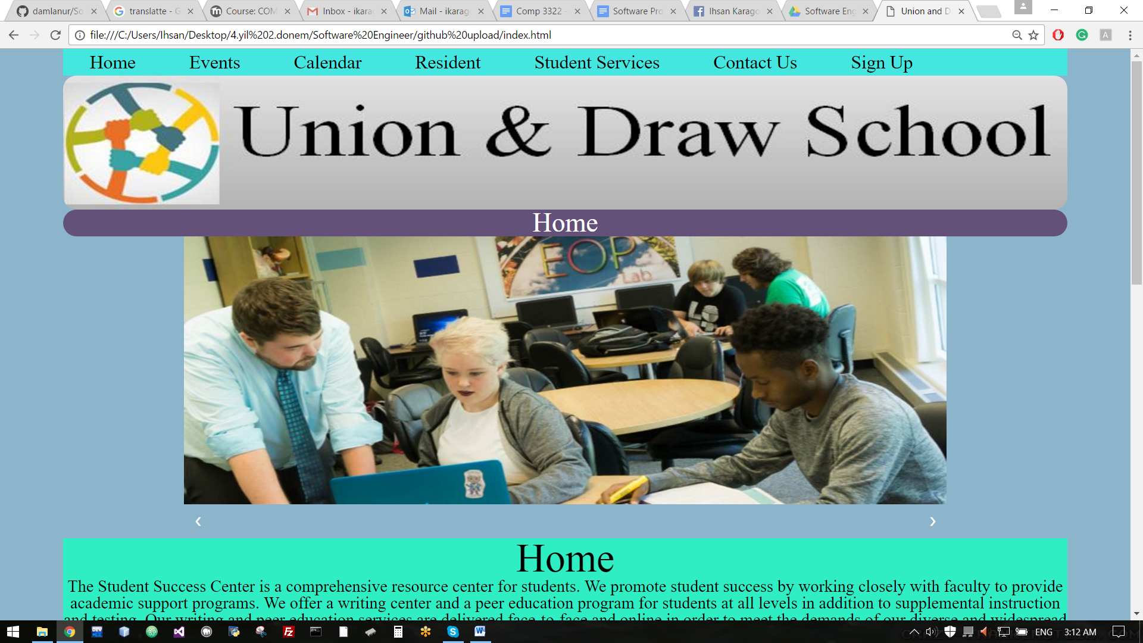 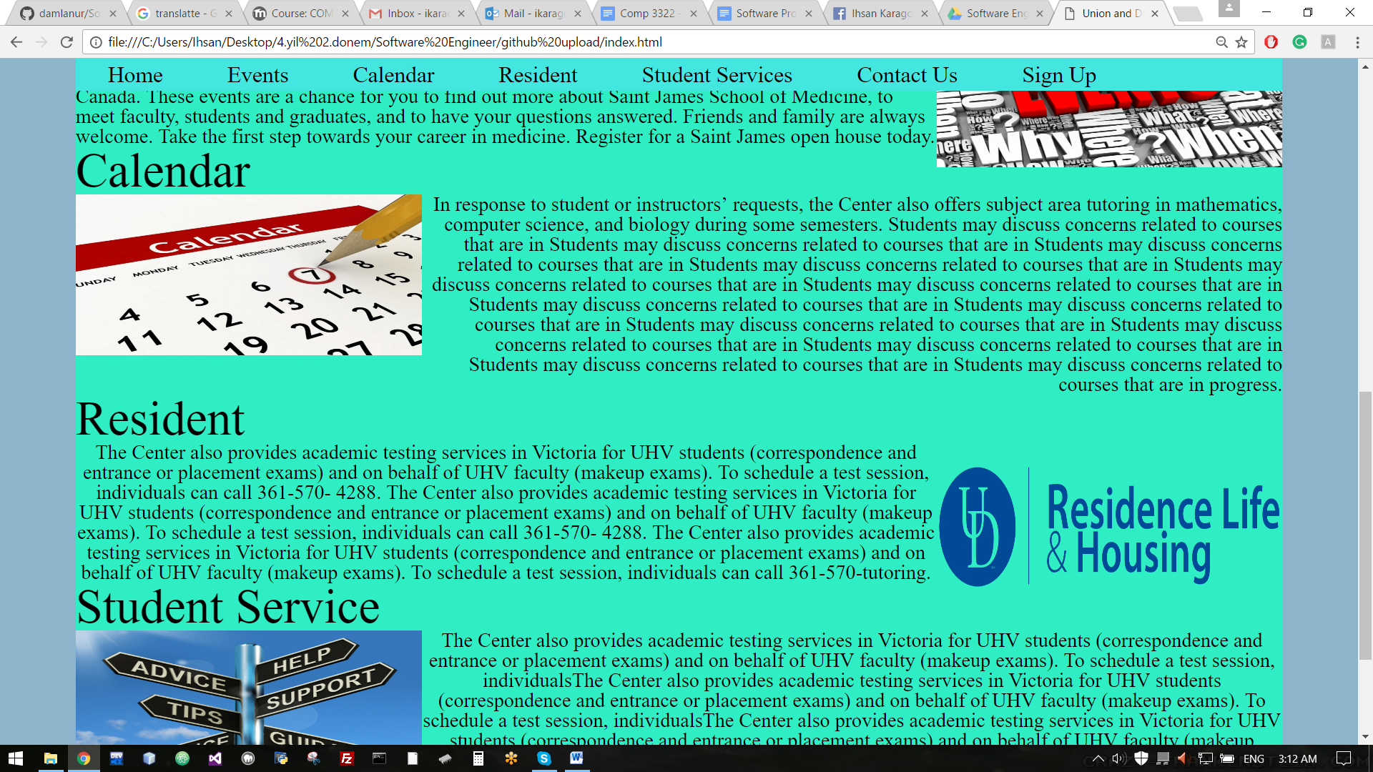 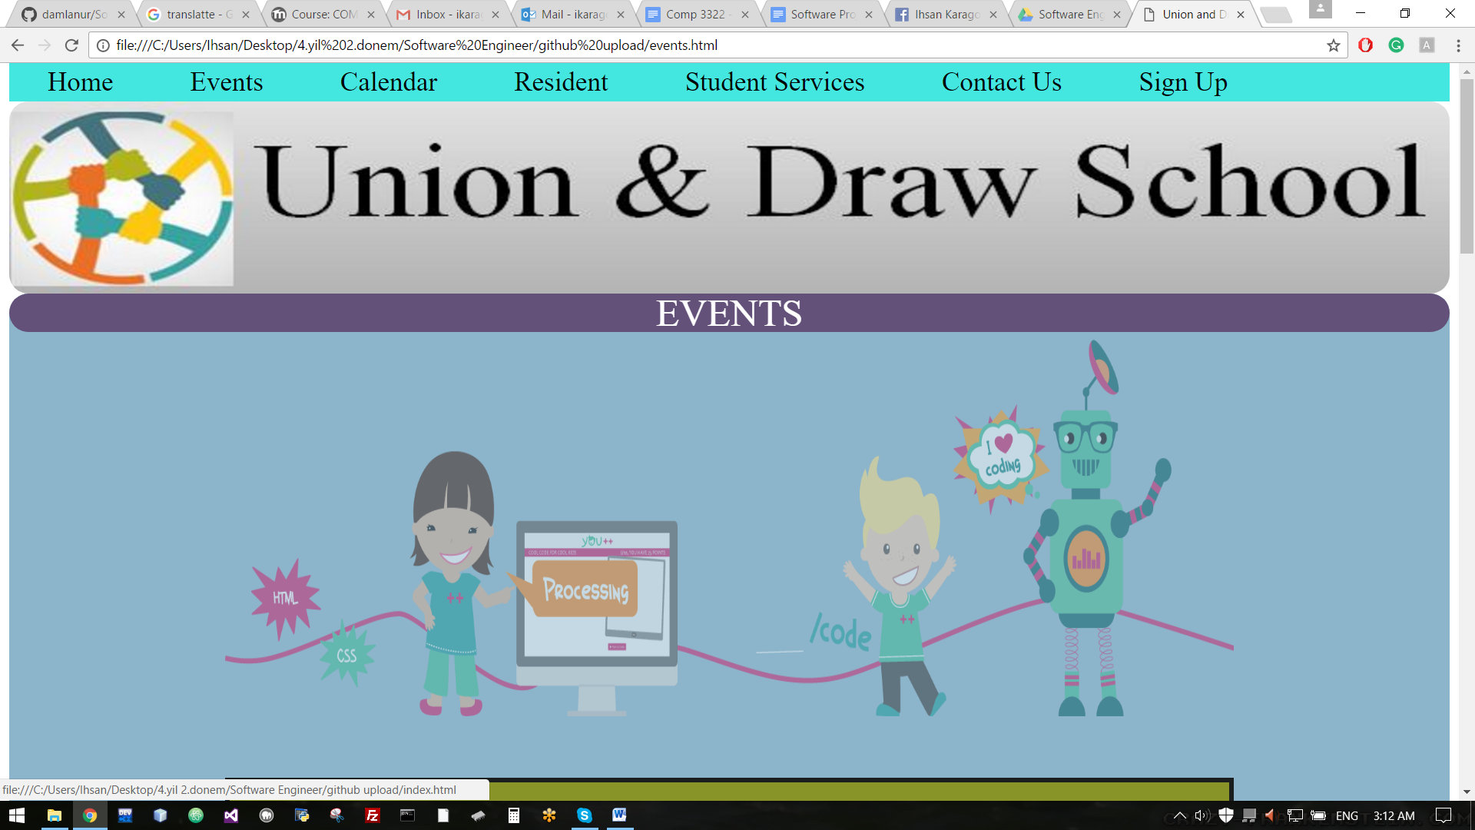 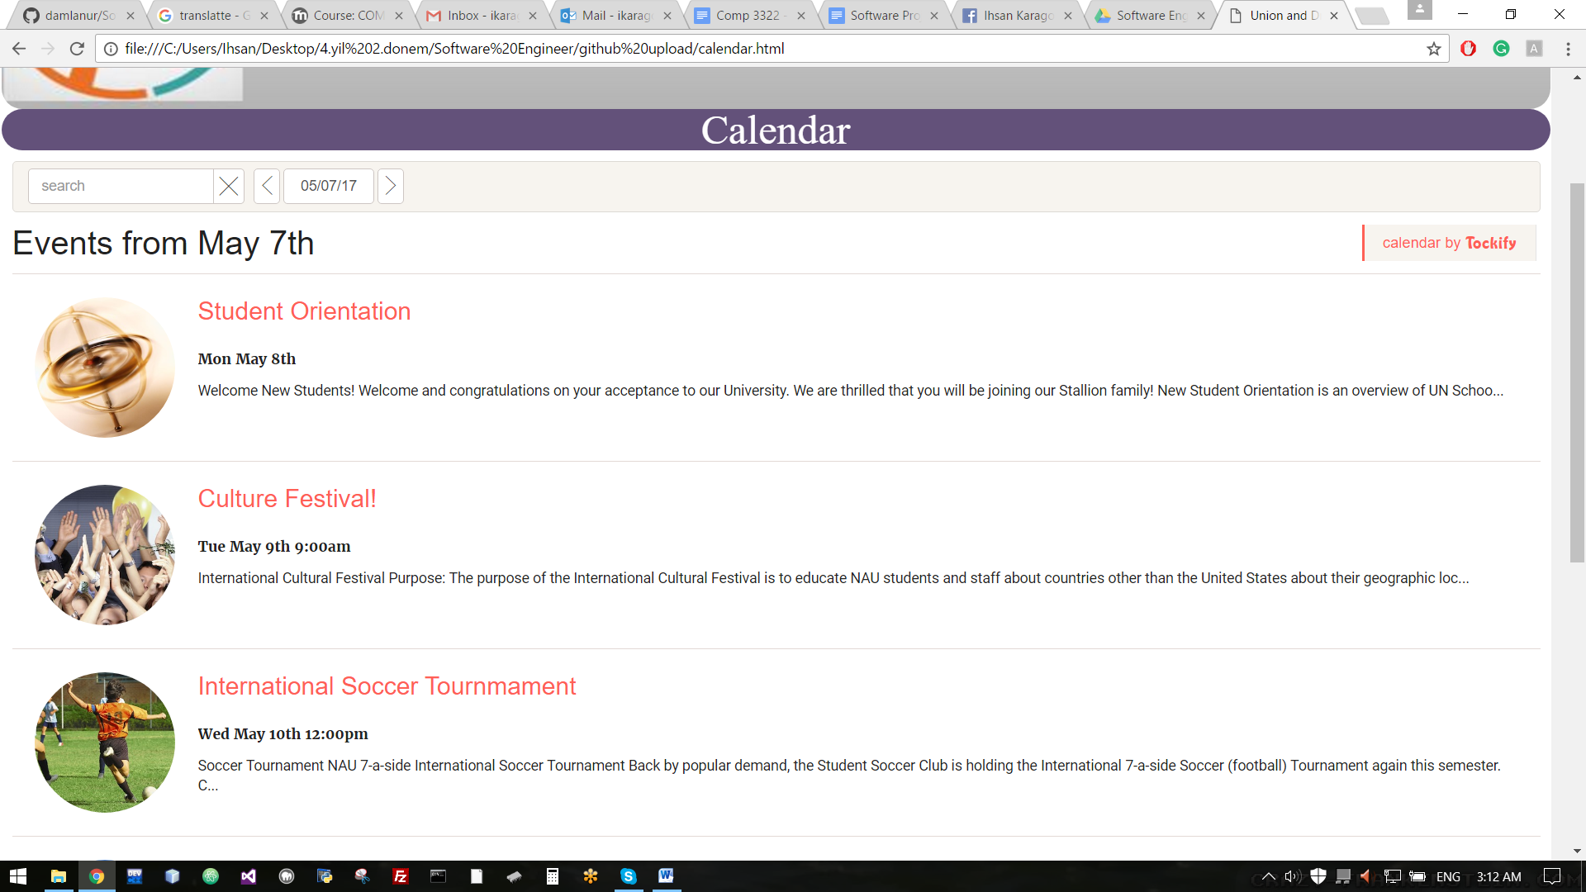 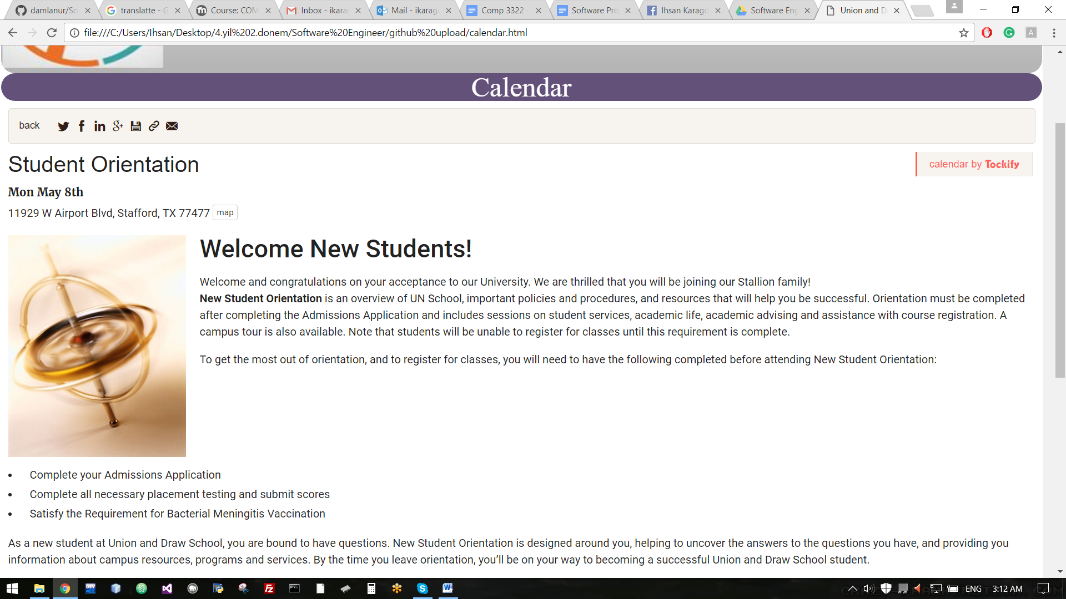 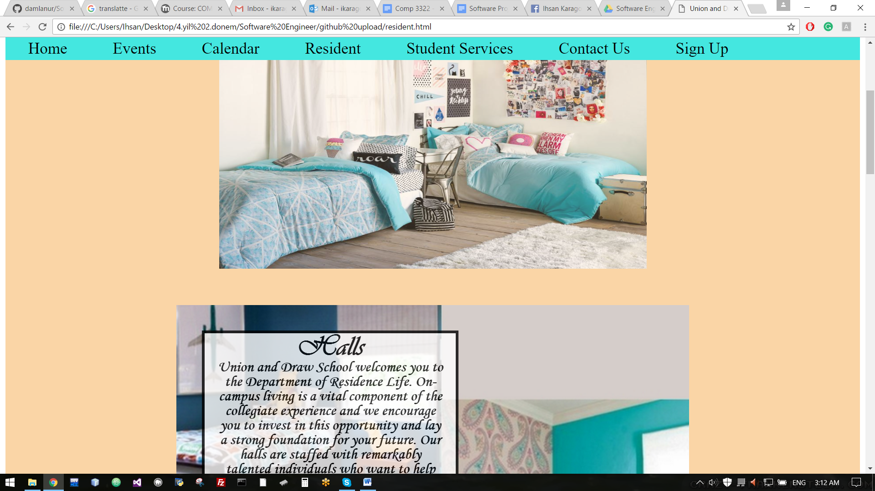  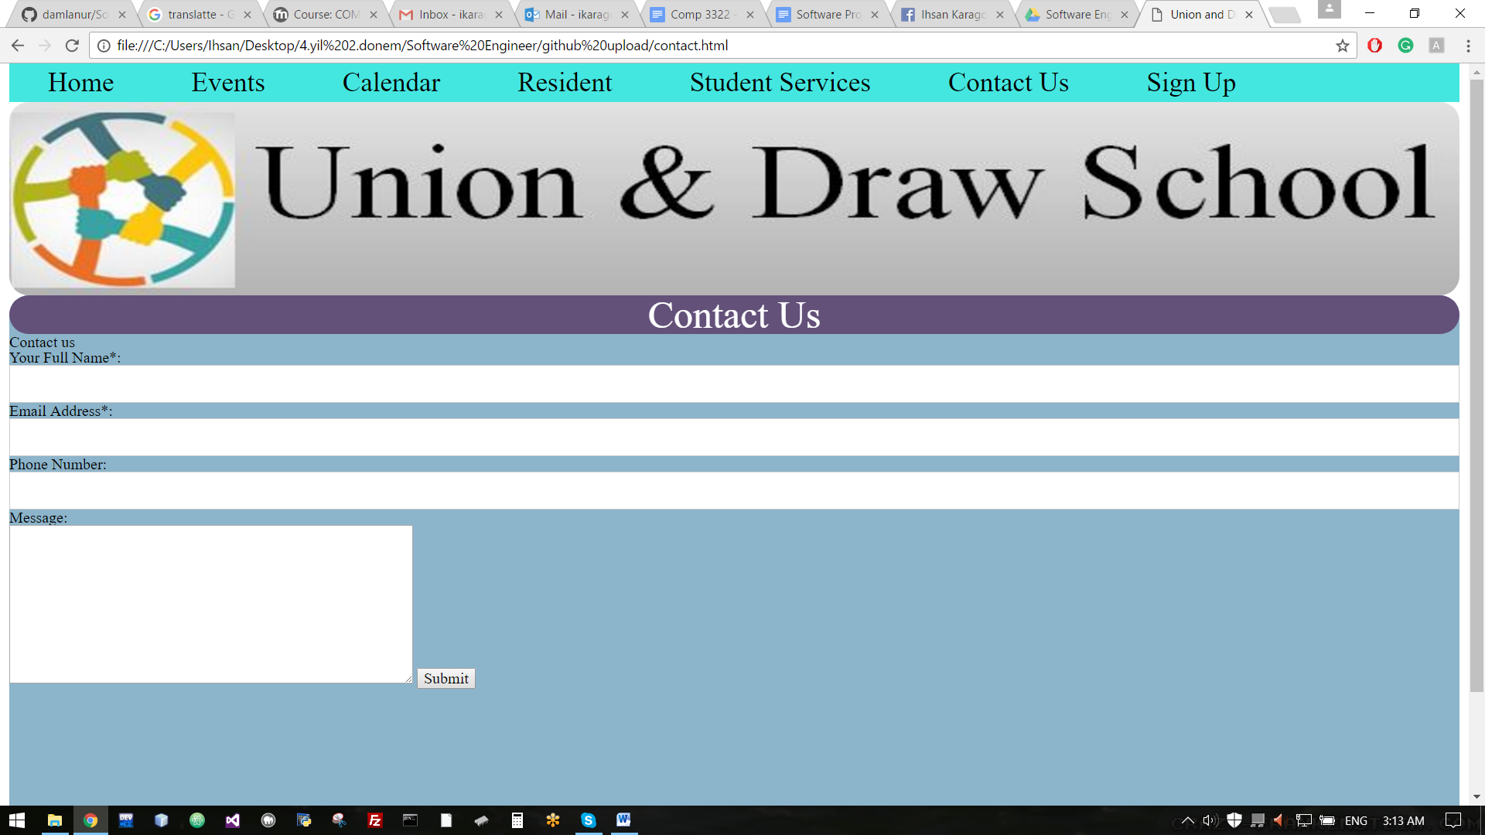 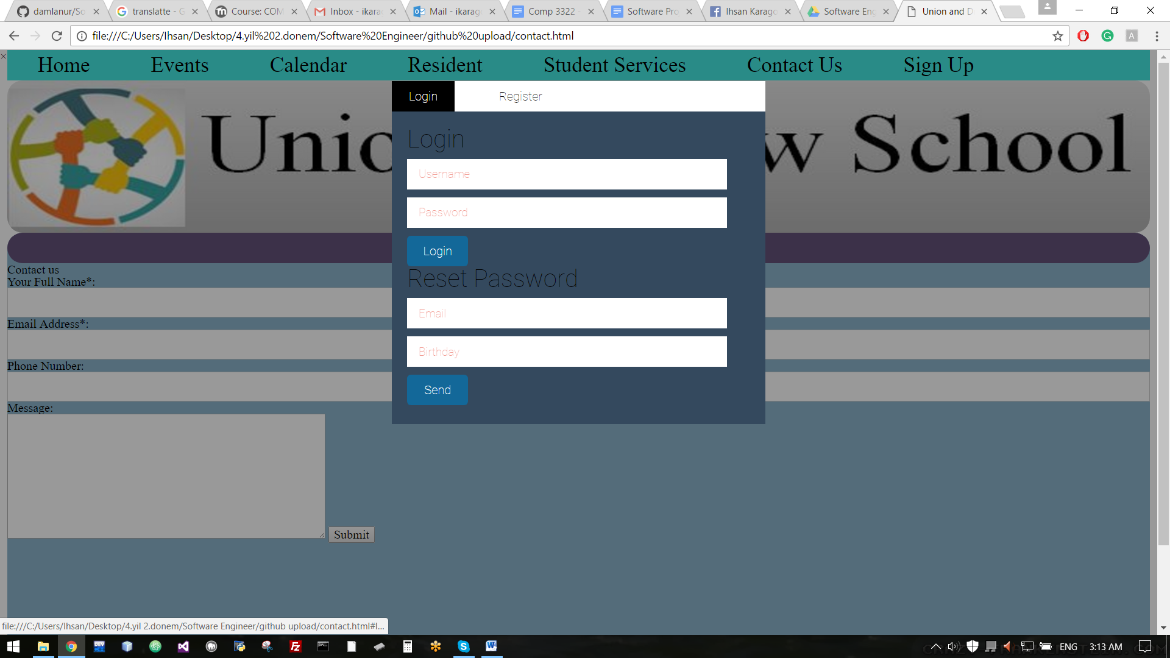 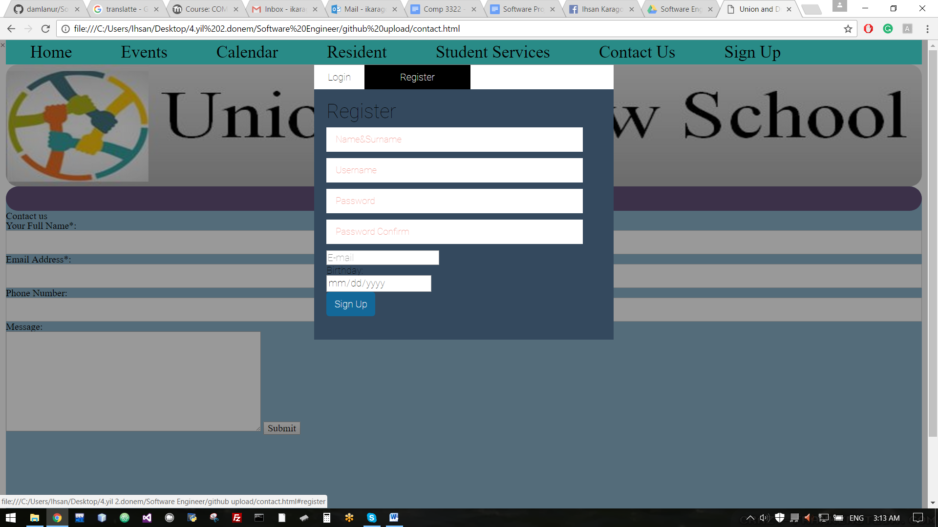

<https://drive.google.com/drive/folders/0B4mSzTZaWzBfTG5xWUplSnE5YnM>

**5.3.1 Repository(Video)**

https://www.dropbox.com/s/xz8klhfzuan2vnc/SE%20fvideo.mp4?dl=0

**5.3.2 Participation**

(add your link that shows contribution of each member)

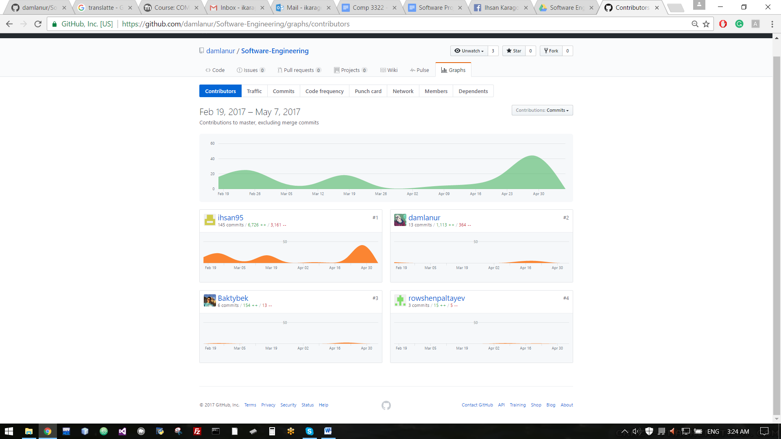

<https://github.com/damlanur/Software-Engineering/graphs/contributors>